**Brooklyn torah gazette**

**For parshas chukas 5782**

Volume 6, Issue 41 (Whole Number 296) 10 Tammuz 5782/ July 9, 2022

**The Weekly Torah Insights of**

**Rabbi Shimshon Dovid Pincus, Zt”l**

**By Daniel Keren**

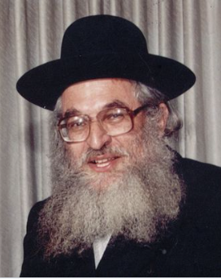

Every week, Jews around the world can choose from dozens if not hundreds of Torah-oriented parsha sheet emails to prepare either before the Shabbos seudos (Sabbath meals) or to read to your family guests or even just yourself at the Shabbos table. My favorite is a recent Torah email – Nefesh Shimshon, which offers Divrei Torah on the weekly parsha and holidays from the teachings of Rabbi Shimshon Dovid Pincus, zt”l.

Rabbi **Shimshon Dovid Pincus** (1944 – 2001) was raised in Brooklyn where he learned in the Beis Hatalmud yeshiva in the Bensonhurst neighborhood where he was greatly influenced by Rabbi Aryeh Leib Malin. He learned in Yerushalayim in the Brisk Yeshiva under Rabbi Berel Soloveitchik, the son of the legendary Brisker Rav (Rabbi Yitzchok Zev Soloveitchik).

After his marriage, he lived in Bnei Brak until accepting the position of Chief Rabbi of a small Jewish community in the Negev town of Ofaqim. A popular Torah lecturer in both Hebrew and English, Rabbi Pincus in addition to delivering shiurim (lectures) throughout the Holy Land, was also in demand for speaking engagement in the Americas and South Africa.

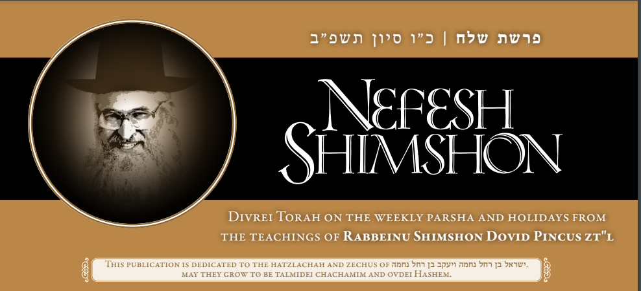

Rabbi Pincus was tragically killed in a car accident that also took the lives of his wife Chaya and his 18-year-old daughter Miriam. Fortunately, hundreds of Rabbi Pincus’ lectures were recorded and to date many of those shiurim have been transcribed into seforim (books) in both Hebrew and English.

In English, Feldheim Publishers has published transcribed books of Rabbi Pincus’ Torah teachers – three volumes of Moadei Hashanah on the different Jewish holidays, and books on faith, Shabbos Kodesh, how to attain Torah, and prayer.

The new Torah email – Nefesh Shimshon – is a project of Kollel “Nefesh Shimshon” in Jerusalem as an illui neshama for Rabbi Shimshon Dovid Pincus, zt”l. The Kollel is headed by his sons – Rav Yosef Dov Pincus and Rav Shmuel Pincus.

It is a beautifully edited and produced Torah email that would enhance the Shabbos or Yom Tov table of all English-reading Jews across the entire spectrum of the Jewish community – whether one is hareidi (ultra-Orthodox) or Modern Orthodox, whether one is Ashkenazi or Sephardi or one is Yeshivish or simple of a “simple” baal habayis.

The average Nefesh Shimshon weekly Torah email consists of seven easy-to-read pages of Divrei Torah that one can enjoy regardless of the level of one’s Torah education. In the most recent email of Nefesh Shimshon for last week’s Parshat Shelach there were three items, which could have been read at the Shabbos table on Friday night, Shabbos day meal and at the Shalosh Seudos (third Sabbath meal). The titles of the Parshat Shelach email of Nefesh Shimshon were: “Hashem is Alive,” Don’t Forget that Hashem Loves You” and “Think Good.”

If you would like to get a free subscription of the Nefesh Shimshon email, you can email your request to [nefeshshimshon@gmail.com](mailto:nefeshshimshon@gmail.com)

**Uri Zohar, zt”l, – Israel’s Most**

**Famous Baal Teshuva**

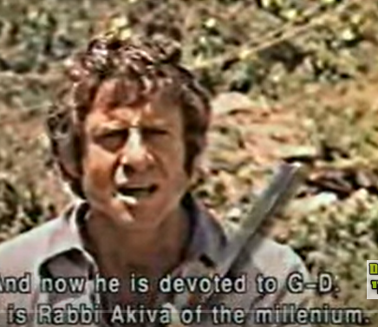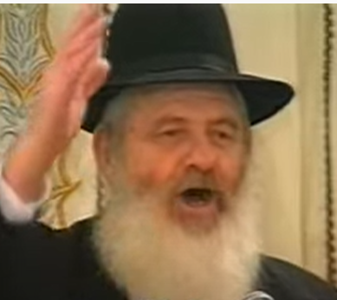

**Uri Zohar – once Israel’s most popular entertainer and later – most famous Baal Teshuvah**

Earlier this month (June 2nd) the Torah world and even secular Israelis were saddened to learn of the petirah (death) of Rabbi Uri Zohar, zt”l, at the age of 86 – once Israel’s most popular entertainer and later the Jewish State’s most famous Baal Teshuva (a secular Jew’s decision to abandon an assimilated life and adopt a Torah-true lifestyle.)

Most Americans have no idea of just how important Uri Zohar was to the chiloni (non-religious) community in Israel. He was a highly regarded and popular Israeli film director, actor and comedian who abandoned the entertainment world in order to become a frum (religious) Jew and an ultra-Orthodox (hareidi) rabbi. To put in the proper perspective, try to imagine how Americans of all faiths would have reacted to a similar baal teshuvah movement of Woody Allen and what a kiddush Hashem that would have created.

Among the YouTube interviews with Rabbi Zohar that I can recommend, is “Frankness Rabbi Uri Zohar Most Ingenious.” Although it is in Hebrew, there are English subtitles and offers one a great opportunity to learn concepts of Rabbi Zohar that he might not have been able to relay in English which is not his mother tongue. It also helps one improve on one’s Ivrit (Hebrew.) For those interested in only a direct English interview with Israel’s most famous Baal Teshuvah, you can google “From Israeli Film to Bnei Brak Gadol – Rabbi Uri Zohar” a recent podcast by the staff of Meaningful People.

**Rav Avigdor Miller**

**On the Happiness Plan**



**QUESTION:** **What should a person do in order to be always happy?**

**ANSWER:** In order to be always happy a person must first choose one thing and concentrate on it until it makes him happy. You have to work on that one thing. After a while you’ll be happy with that one thing. Then add another thing. And work on that. After a while work on something else. After a while you’ll have so many things that you’ll be a rich man. You’ll actually feel a happiness about so many things.

So start out as follows. Say, “I’m happy that I have something to eat.” Learn how to be happy that you have food. Work on that. It takes some effort. Practice that for a while without any weakening of your resolve.

**Learn How to be Happy with**

**Successfully Going to the Bathroom**

Next, you went to the bathroom. Everything worked? Learn how to be happy with that. You hear that?! Learn how to be happy with that. You don’t think about it?! When you’ll be eighty years old you’ll start thinking about it. Trust me, you’ll think about it. And you’ll long for those days of happiness when everything worked so well. So start thinking about it now. Work on being happy that you can go to the bathroom.

Little by little, add. It takes work. It takes time. Like I said before, it doesn’t come by itself. Little by little, you’ll add. And after a while you’ll have forty, fifty things. And that’s nothing yet because there’s so much more than that. But you’ll be happy with forty things and you’ll be a rich man. You’ll be a rich man already. And if you’re a young man yet – even a young man of sixty – you’ll keep on this path, on this career, until you’re in your nineties and you’ll be a very wealthy person.

**You Have to Make Up Your Mind**

**To Pursue a Career of Happiness**

But you have to do it, though. Just hearing me say it, is not enough. You have to make up your mind that you’re going to pursue this career of happiness and that you’ll always be saying, “I thank You Hashem.” Always, “I thank You Hashem for giving me this breakfast.” “I thank you Hashem for being able to go to the bathroom.” And don’t rely on the  brachos you make. You must say it with your mouth in your own language.

Always. And, המחשבה נמשכת אחר הדיבור – your mind will be transformed because of your speech and you will become a happy man. You will become happy with the so many wonderful things that you have always taken for granted. And you will become a servant of Hashem and a great man. Not only will you become a happy person but you will become a great person. TAPE # E-202 (July 1999)

*Reprinted from June 2, 2022 email of Toras Avigdor. Adapted from Tape #R-E-202 (July 1999)*

**Appreciating G-d’s Eternal Gifts to the Jewish People in the Desert - the Clouds**

**Of Glory, the Manna & the Well**

**From the Talks of the Lubavitcher Rebbe**

**Rabbi Menachem Mendel Schneerson, Zt”l**

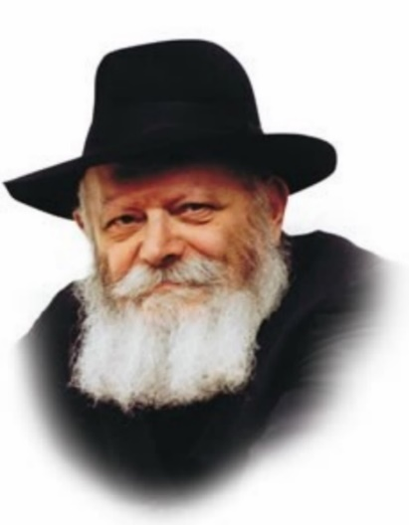

Our Sages discuss the clouds of glory, the well and the manna we read about in this week's Torah portion, Chukat.

The clouds of glory surrounded the Jews and guarded them. They protected them from the wind, killed snakes and serpents, leveled the mountains as they walked through the desert and cleaned their clothes.

The manna was the food the Jewish people ate in the desert. It had any taste a person wanted; each individual experienced a different flavor when he ate it. Ingested and assimilated into the Jew's physical body, it became part and parcel of their flesh and innermost being.

**Provided in the Merit of Miriam**

The well, provided by G-d in the merit of Miriam, supplied the Jews with water. Water, although not a food in its own right, is nonetheless the means by which nourishment is transported to all parts of the body.

Allegorically speaking, these three phenomena -- the clouds, the manna and the well -- are also found in Torah. Like the clouds, the Torah protects us from without. Like the manna, it enriches our inner being and becomes united with it. And like water, Torah is the means by which these inner and outer qualities are conveyed to all Jews.

Let us look at each of these phenomena individually:

**Understanding the Uniqueness of Every Jew**

The manna, which permeated the Jew's inner essence, was not given in an equal manner or in equal proportions to everyone. Righteous people were given manna that was ready to eat; the wicked had to grind and cook it to make it edible. Why? Because internally, every Jew is different.

For one Jew, reciting "Shema Yisrael" is enough to fulfill the mitzva of learning Torah, yet another must sit and study a whole day! The Torah's demands are dependent on a person's individual situation and circumstances; his obligations are in exact proportion to his ability.

The clouds, by contrast, surrounded all the Jews equally, without distinction. The clouds protected everyone, in a place rampant with snakes and scorpions. The desert is symbolic of this world, in which people often encounter difficulties. Similarly, the Torah encompasses all Jews, protecting every member of the Jewish people. The essence of the Jewish soul is the same in every Jew. Likewise, the Torah belongs equally to all of us.

**The Power of the Torah to Effect Every Jew**

Lastly, water flows from a high place to a low place. (In fact, the Torah has descended from the very highest of spheres to the lowest -- the physical world in which we live.) It conveys the Torah's "manna" and the Torah's "clouds of glory" to every Jew. And when a Jew reads the Torah, he receives its "manna" and "clouds" -- even if he does not understand the meaning of the words.

*Reprinted from the Parshat Chukat 1997/5757 (Issue #476) edition of L’Chaim Weekly, a publication of the Lubavitch Youth Organization in Brooklyn, NY. Adapted from Likutei Sichot, Volume 2.*

**Rabbi Berel Wein on**

**Parshat Chukat 5782**

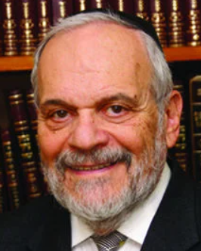

The Torah reading of this week deals with a ritual in the Temple – that of the Red Heifer – which is characterized as being a commandment beyond the ken of human understanding and rational interpretation. It remains a primary example of certain commandments that, at their very core, are not easily interpreted or made relevant to human behavior, nor to moral understanding and judgment.

The Torah itself calls this commandment a *chok*, which must be obeyed without question or doubt, for it is beyond human comprehension and understanding to genuinely appreciate and value its essence and purpose. This is the reason the entire Torah reading of this week is called *Chukat* – the law and commandments of the Torah for which no explanation will be given.

If we review previous narrative portions of the Torah that we have read and studied over the past weeks, we can easily conclude that all the events that were described – the murmurings, rebellions, false reports and evil speech and the crimes against Moshe and Aaron also fit the category of being a *chok* – something irrational, inexplicable and beyond logical comprehension.

We all believe, somehow, that we live in a rational world, and that we can make rational decisions based upon knowledge, facts, experience, and history. However, the truth is that very few of our decisions are made rationally and are often based on other factors on a constant and recurring basis. Human behavior is almost by definition irrational and inexplicable. It is because of this truth that the Torah gives us laws and commandments that are rational and inexplicable, to match our human moods and decision-making processes.

We can easily understand that if it were not for the Torah itself guiding us through life, giving us daily support, guidance, and stability, certainly the national life of the Jewish people would be chaotic in the extreme. It is this chaos of irrational behavior which is universally present amongst all people in the world, which leads to the fall of empires and to catastrophic decisions brought about by irrational policies and a great deal of human arrogance.

It is noteworthy to see that in world history, almost all the major empires of the world collapsed and eventually fell because of internal pressures of the society rather than by actual external aggression. These pressures are caused by human nature, both emotionally and ideologically. Once the original basis and emphasis that brought about success and growth in the Empire dissipated, because of the irrational behavior of leaders of these empires, the collapse of those would not be long in coming.

I have always found it to be ironic that the most irrational of all creatures – human beings – have the temerity to criticize Jewish tradition as not being rational or easily explained in so-called “factual” terms. It is the purpose of the Torah to instruct us, guide us, and constrain us. It is the purpose of the Torah to counter human irrationality with a form of heavenly certainty that is beyond our understanding. History has proven this assertion correct.

*Reprinted from the current website of rabbiwein.com*

**Rav Aharon Lewin, Zt”l – The Reisha Rov**

**By Avrohom Birnbaum**

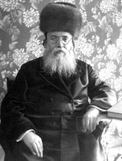

**Rav Aharon Lewin, Hy”d**

Rav Aharon Lewin rabbi of Rzeszow / Reisha, Poland and a member of the Polish Sejm / parliament was born on 14 Elul, 5640 (1879) in the Galician city of Pshemishel. His parents, Rav Nosson and Rebbetzin Hadassah Lewin, were the son-in-law and daughter of the Rov of Pshemishel and then Lemberg, Rav Yitzchok Shmelkes, author of the famed Sheilos U’Teshuvos Bais Yitzchok.

As a young boy, Aharon spent much time with his grandfather, Rav Yitzchok Shmelkes. The Bais Yitzchok invested his heart and soul into the chinuch of his grandson and even from a very young age, it was evident that young Aharon possessed tremendous intellect and insight.

Both his father and grandfather taught him Torah and by the time he became a bar mitzvah, it was clear that a new star was beginning to shine on the horizon of Poland’s rabbinical world.

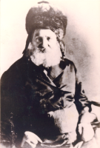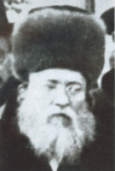

**Rav Yitzchok Shmelkes, zt”l grandfather of the Reisha Rov (left) and Rav Nosson Lewin, father of the Reisha Rov**

In the Machzikei Hadaas newspaper published in Poland in the month of Cheshvan, 5653 (1892), there is a paraphrased report about the remarkable bar mitzvah of the young bochur, Aharon Lewin:

“Last week, the bar mitzvah of the wonderful, brilliant and erudite bochur, Aharon Lewin, grandson of the great Rov, Rav Yitzchok Shmelkes, was held. On Shabbos, the bar mitzvah bochur gave a beautiful drasha in the city’s main shul. The drasha was a masterful presentation of pilpul and sevorah — the boy posed a clear delivery and his words of aggadah were listened to raptly by the entire shul which was packed from one end to the other.

“All of the distinguished members of the community came to hear the young boy’s drasha. They all seemed amazed over the fact that such a young bochur spoke with such confidence before such a large crowd. After the drasha, the entire community converged to wish him mazal tov and express their deep feelings that he continue to benefit Jewry with his special gifts of Torah and chochma.”

Indeed, it seemed as if the heartfelt brachos of so many Jews were fulfilled in the boy because after his bar mitzvah over the course of a few years, the young bochur began to develop and mature into a true gaon. He was soon considered among the most erudite talmidim of his illustrious grandfather.

In the third volume of the sefer Bais Yitzchok (published in 1894), we find chiddushim in the name of the young 15 year old Aharon Lewin. He also completed the Maftechos – indexes for the sefer. The last two volumes of Bais Yitzchok contain many chiddushim from Rav Aharon, all written when he was a bochur.

When he was in his late teens, Rav Aharon Lewin was already assisting his grandfather in many areas of the rabbinate of the city of Lemberg (Lvov) where Rav Yitzchok had since moved to from Pshemishel. Lemberg (Lvov) was the capital of Galicia and all of the most difficult halachic and communal matters arrived at the door of Rav Yitzchok who was one of the gedolei hador.

**Discussions Between Grandfather and Grandson**

He would discuss most of these matters with his young grandson and through these conversations, Rav Aharon absorbed the appropriate rabbinical approach to a whole host of halachic and communal matters. Even as a bochur, his talent as a public speaker was public knowledge. Once, when he was 19 years old, he gave a drasha at the “Koveia Ittim L’Torah” Shul. His drasha was so powerful and made such a profound impact on his listeners that they begged him to publish it so that others could also benefit from it.

Thus the sefer “Dovor B ‘Ito” was printed in 1899, containing that seminal drasha.Once, when both he and his grandfather, the Bais Yitzchok delivered drashos one after the other in the main shul in Lvov, the Bais Yitzchok asked one of the prominent members of his kehillah for his opinion of his grandson’s speech. The man replied, “I will respond with the words of the possuk (Shmuel 1:18-7) Hikah Shaul b’alufav v ‘Dovid birivivosov—Shaul has slain his thousands and Dovid, his tens of thousands.”

The Bais Yitzchok laughed and took great pride in the comment. While he was growing in Torah and learning with great hasmodah with his grandfather, Rav Yitzchok gave his consent to Rav Aharon taking the time to learn the two secular languages most prevalent in that area, Polish and German. He became completely fluent in both languages and spoke them with the fluency of his mother tongue.

**Wrote Articles in Polish**

He began to write articles in Polish. His expert knowledge of both languages would eventually serve as an instrumental tool in his being able to improve the lot of his Jewish brethren. In 1902, Rav Aharon married Dobbah, daughter of Rav Eliyahu Tzvi Friedman from the town of Vielitchka near Krakow. Rebbetzin Dobbah Lewin represented the grace, tznius and middos tovos of a bas Yisroel. Throughout their nearly 40 years of marriage, she stood by her husband’s side with great fortitude, wisdom and purity.

The Lewins established a wonderful family, a daughter, Preva followed by three sons –Yitzchok Lewin and the twins, Shmuel Dovid and Mordechai Lewin. Before his wedding, Rav Ahron’s grandfather, the Bais Yitzchok, wrote him an enthusiastic semicha document. It began, “Although it is well known that a father, by virtue of his closeness, cannot give testimony on his own son and this grandson of mine is like a dear son to me whom I raised, nevertheless, something that is well known to all does not require testimony.”

The Bais Yitzchok continued to extol the virtues and scholarship of his grandson “who is destined to illuminate the rabbinic world”. Rav Aharon also received semicha from Rav Chaim Aryeh Horowitz, Av Bais Din of Krakow and Rav Binyomin Aryeh Weiss, Av Bais din of the city of Chernowitz. (Yated Ne’eman, 29 Sivan 5770 – June 11, 2010.)

*Reprinted from the Parshat Chukat 5782 email of R’ Yedidye Hirtenfeld’s parsha sheet whY I Matter for the Young Israel of Midwood in Brooklyn.*

**Thoughts that Count**

This is the statute of the Torah... and they shall take to you a red heifer (Num. 19:2)

In speaking of the laws of the red heifer, the Torah states, "This the statute of the Torah," not just the statute of the red heifer. The red heifer has the power to purify one who was defiled, yet those who partake in the preparation of the red heifer become defiled. The verse is teaching us one of the basic lessons of the Torah, that we are obligated to help our fellow Jew, even if it requires sacrifice. *(The Lubavitcher Rebbe, zt”l)*

And Miriam died there and she was buried there (Num. 20:1)

It is significant to mention both facts, that Miriam died and she was buried. During the forty years that the Jews wandered in the desert as a punishment for speaking ill of the Land of Israel, every year those people who were between the ages of twenty and sixty at the time of the exodus would dig graves for themselves and went to sleep in them. Those who were meant to die did, and those who did not die returned to their tents. Therefore, Miriam was the only person at that time who died before she was buried. *(Sh'nei Ham'orot)*

G-d said to Moses and Aaron, "Because you did not believe in Me to sanctify Me in the eyes of the Children of Israel, therefore you will not bring this congregation into the land I have given them." (Num. 20:12)

Aaron was punished, as well. For, Moses hit the rock twice and Aaron should have stopped him after the first time, telling him that the commandment was to speak to the rock and not to strike it. *(Shaar Bat Rabim)*

*Reprinted from the Parshat Chukat 5757 edition of L’Chaim Weekly. Excerpted from the sefer Vedibarta Bam by Rabbi Moshe Bogomilsky*

**Italian Small Megilla**

**Esther Scroll**

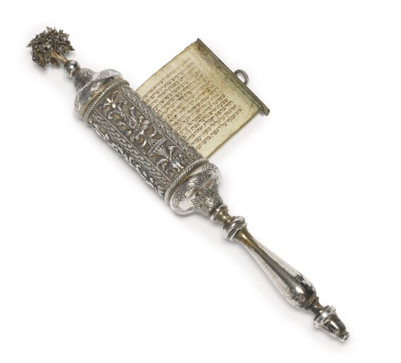

**This 19th Century (circa 1825) Italian Judaica item sold in the 2013 Sothebys Judaica auction in New York for $11,250.**